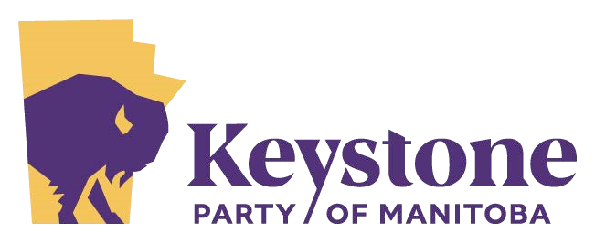

info@keystoneparty.ca

November 15, 2022
Office of the Premier of Alberta
307 Legislature Building
10800 – 97 Avenue
Edmonton, AB
T5K 2B6

Office of the Premier of Saskatchewan
Legislative Building
Room 226
2405 Legislative Drive
Regina, SK
S4S 0B3

Dear Premier Danielle Smith and Premier Scott Moe,

I am writing to express our interest in the recent proposal by Premier Smith for a meeting in Churchill to discuss ways in which the Prairie provinces can cooperate on the constitutional and resource development fronts.

On behalf of the Keystone Party of Manitoba, I would like to encourage proceeding with this meeting at the earliest opportunity.

The Keystone Party is supportive of the sovereignty legislation your Parties have been promoting and the potential flowing therefrom for the development and export of our energy, agriculture and other commodities to the world at this urgent time. We are disappointed that Manitoba’s governing Stefanson PCs have declined to participate in this important initiative.

Nonetheless, we respectfully request that the Keystone Party be included in your discussions around the construction of pipelines, powerlines, roads and railways within a resource corridor culminating at the Port of Churchill or at Port Nelson.

We are inspired by the prospect of liberating our resources from landlocked status – as well as for the renaissance of our agricultural, forestry, mining and hydroelectric sectors. Our one caveat would be that this urgent initiative is led exclusively by the private sector, with the government’s role limited to:
- Remove regulatory obstructions;
- Granting tax credits, exemptions or holidays;
- Privatizing Crown land for the creation of the corridor itself;

An additional consideration is preferential investment opportunities for residents of Alberta, Saskatchewan and Manitoba to allow our citizens to share in the prosperity this project is sure to generate.

We must not place taxpayers at risk the way governments have done with the Trans Mountain Expansion project (TMX) or the Keystone XL pipeline – both of which cost the public billions of dollars (and counting in the case of TMX).

We must also ensure the protection of property rights for both Indigenous and Non-Indigenous landowners along the proposed route. Also of paramount importance is prudent environmental stewardship on any impacted lands.

The Keystone Party of Manitoba looks forward to expanding on these ideas in Churchill as soon as accommodations can be arranged. The economic renaissance promised by an assertion of the powers granted to the provinces within confederation must be seized now. Our northern and Indigenous populations have waited too long for prosperity.

Albertans, Saskatchewanians and Manitobans deserve the opportunity to create our own destiny through the visionary strategies initiated by your governments – without interference from Ottawa. More urgently, Manitobans seek to share in this vision and opportunity because it creates a way to leave our “have not” status behind and presents a path forward to the prosperity this province once knew.

Premiers, it is our hope that you will see fit to accept the Keystone Party as Manitoba’s partners in the promotion of this historic undertaking.

Yours truly,
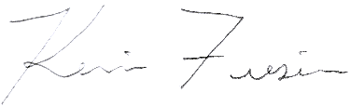
Kevin Friesen, Leader

Keystone Party of Manitoba
Box 904
Grunthal, MB
R0A 0R0

