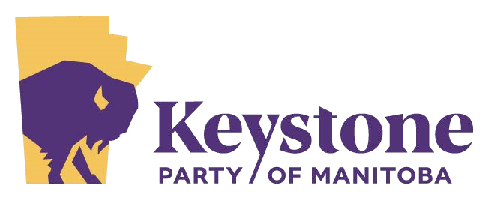

Press Release October 5, 2023
The Keystone Party would like to express appreciation for the thousands who supported us by contributing their time and finances to our campaigns and for those who supported us by voting for our candidates.
Manitobans have discovered that they have an alternative. Our candidates had roughly 90 days and limited resources to create and run an election campaign, placing third in each of the five ridings, that we ran candidates, Keystone is showing that we are a force to be reckoned with.
We look forward to the next election in 2027. In the meantime, we encourage the many who expressed disappointment that we did not have a candidate in their riding to join with their neighbours, form a constituency association and join us in writing the policies most important to Manitobans at our 2025 convention.
In 2026, constituency associations will be choosing candidates to represent them. These candidates will bring the concerns and priorities of their constituents to the Manitoba Legislature.
We are not going to sleep between elections; we will be watching the legacy parties and listening to our constituents to position ourselves to become the choice that Manitobans make on Election Day in 2027.

